**ABSTRACT**

Cardiovascular diseases are the most common cause of death worldwide over the last few decades in the developed as well as underdeveloped and developing countries. Early detection of cardiac diseases and continuous supervision of clinicians can reduce the mortality rate. However, accurate detection of heart diseases in all cases and consultation of a patient for 24 hours by a doctor is not available since it requires more sapience, time and expertise. In this study, a tentative design of a cloud-based heart disease prediction system had been proposed to detect impending heart disease using Machine learning techniques. For the accurate detection of the heart disease, an efficient machine learning technique should be used which had been derived from a distinctive analysis among several machine learning algorithms. Machine Learning is used across many spheres around the world. The healthcare industry is no exception. Machine Learning can play an essential role in predicting presence/absence of Locomotor disorders, Heart diseases and more. Such information, if predicted well in advance, can provide important insights to doctors who can then adapt their diagnosis and treatment per patient basis. And in addition we also predicting the kidney diseases using the machine learning. Algorithms like Random Forest, Support Vector Machine, Naïve Bayes and etc.,

**1.INTRODUCTION**

Versatile gadgets for the home observing of heart wellbeing are relied upon to observe significant development in coming years. The expanding rate of cardiovascular ailment, the expansion in geriatric populaces and the interest for autonomous living are driving the development of remote observing gadget markets [1]. Electrocardiography (ECG) is as yet the most generally utilized diagnostics instrument in emergency clinics and at home. The estimation hardware for ECG, nonetheless, isn't promptly accessible for most patients, so they should obtain it and learn step by step instructions to utilize it. An elective mood the board strategy, mechanocardiography (MCG), depends on estimating the mechanical movement actuated by the heart [2]. Today, the sensors suited for this purpose accelerometers and gyroscopes integrated into most smartphones and are available for most people. Combined with their ease of use, these devices have potential as a low cost home health monitoring solution. Current wearable/handheld cardiac monitors can be divided into three groups. Monitors in the first group, such as ECG and impedance cardiography (ICG), measure electrical signals produced by heart’s activity. The second group comprises methods that measure volumetric blood pressure variations using optical sensors, such as those in photoplethysmography (PPG), which are placed on fingertips, toes, earlobes, wrists and the face. The third gathering incorporates mechanical heart observing, for example, ballistocardiography (BCG), which distinguishes changes in body pull back powers in light of blood discharge from the aorta to the vascular tree. Seismocardiography (SCG), which estimates positional developments of the chest divider because of precordial vibrations, likewise has a place with the third gathering. An integral estimation strategy to SCG has developed: gyrocardiography (GCG). With the most recent innovative improvements, these sensors have sensible control utilization and superior. Gyrators have higher resilience to clamor, and the got waveforms stay more monomorphic and stationary than they do in seismocardiograms.

Cell phone mechanocardiography (sMCG) is a key application for the created technique as it is completely ECG-free furthermore, requires neither a preparation stage nor any earlier information about the morphology of heart thumps in GCG/SCG signals. Remote pulse observing utilizing cell phones and mHealth applications can before long be saddled for beat the board and cardiovascular malady checking [2]. In any case, MCG signals will in general have relational varieties because of individual contrastences, for example in sensor arrangement, weight record (BMI), age, sex, substantial and wellbeing conditions, coming about in incomprehensibly assorted beat morphologies. In addition, MCG signals are vulnerable to movement ancient rarities that can without much of a stretch eclipse the musicality signal what's more, in this way, the nature of the account [10], [11]. For these reasons, beat-to-beat discovery from mechanical movement signals with exact planning and sufficiency data is as yet one of the fundamental difficulties in the investigation of these sign. In this investigation, a sensor methodology and calculation combination of programmed and remain solitary (ECG-free) heart beat detection is considered for improved heart beat identification. The examination was done with sound patients and those with coronary illness. The calculation chooses the best sign, expels the movement curios, identifies the beats dependent on the signal envelope and morphological attributes, and lastly blends the recognized beat areas utilizing both accelerometers also, whirligig signals. This paper is composed as pursues: Section II depicts information procurement. Area III gives the subtleties of the created calculation, and Section IV exhibits the outcomes and discourse of the displayed work, trailed by the closing Section.

**Scope**

The goal of this study is to develop a reliable multi-channel MCG based IHD early detection and localization system. The database came from a retrospective study of cardiovascular disease including multiple hospitals in China. Coronary angiography was applied to IHD group as the gold standard, and the detailed medical records, including the degree and location of stenosis, were well documented. The feature design integrated MCG features from time domain, frequency domain and information theory.

**2. LITERATURE SURVEY**

# Title 1: Automatic Detection of Seismocardiogram Sensor Misplacement for Robust Pre-Ejection Period Estimation in Unsupervised

**Author:** H. Ashouri and O. T. Inan,

Seismocardiography (SCG), the measurement of the local chest vibrations due to the movements of blood and the heart, is a non-invasive technique for assessing myocardial contractility via the pre-ejection period (PEP). Recently, SCG-based extraction of PEP has been shown to be an effective means of classifying decompensated from compensated heart failure patients, and thus can be potentially used for monitoring such patients at home. Accurate extraction of PEP from SCG signals hinges on lab-based population data (i.e., regression curves) linking particular time-domain features of the SCG signal to corresponding features from reference standard bulky instruments such as impedance cardiography (ICG). Such regression curves, in the case of SCG, have always been estimated based on the "ideal" positioning of the SCG sensor on the chest. However, in settings such as the home where users may position the SCG measurement hardware on the chest without supervision, it is likely that the sensor will not always be placed exactly on this "ideal" location on the sternum, but rather on other positions on the chest as well. In this study, we show for the first time that the regression curve for estimating PEP from SCG signals differs significantly as the position of the sensor changes. We further devise a method to automatically detect when the sensor is placed in any position other than the desired one in order to avoid inaccurate systolic time interval estimation. Our classification algorithm for this purpose resulted in 0.83 precision and 0.82 recall when classifying whether the sensor is placed in the desired position or not. The classifier was tested with heartbeats taken both at rest, and also during exercise recovery to ensure that waveform changes due to positioning could be accurately discriminated from those due to physiological effects

**Title 2:** Unobtrusive nocturnal heartbeat monitoring by a ballistocardiographic sensor in patients with sleep disordered breathing

**Author:** M. D. Zink, C. Bruser, B.-O. St ̈ uben, A. Napp,

Sleep disordered breathing (SDB) is known for fluctuating heart rates and an increased risk of developing arrhythmias. The current reference for heartbeat analysis is an electrocardiogram (ECG). As an unobtrusive alternative, we tested a sensor foil for mechanical vibrations to perform a ballistocardiography (BCG) and applied a novel algorithm for beat-to-beat cycle length detection. The aim of this study was to assess the correlation between beat-to-beat cycle length detection by the BCG algorithm and simultaneously recorded ECG. In 21 patients suspected for SDB undergoing polysomnography, we compared ECG to simultaneously recorded BCG data analysed by our algorithm. We analysed 362.040 heartbeats during a total of 93 hours of recording. The baseline beat-to-beat cycle length correlation between BCG and ECG was rs = 0.77 (n = 362040) with a mean absolute difference of 15 ± 162 ms (mean cycle length: ECG 923 ± 220 ms; BCG 908 ± 203 ms). After filtering artefacts and improving signal quality by our algorithm, the correlation increased to rs = 0.95 (n = 235367) with a mean absolute difference in cycle length of 4 ± 72 ms (ECG 920 ± 196 ms; BCG 916 ± 194 ms). We conclude that our algorithm, coupled with a BCG sensor foil provides good correlation of beat-to-beat cycle length detection with simultaneously recorded ECG.

**Title 3:** An algorithm for the beat-to-beat assessment of cardiac mechanics during sleep on earth and in microgravity from the seismocardiogram

**Author:** M. Di Rienzo, E. Vaini, and P. Lombardi

Seismocardiogram, SCG, is the measure of precordial vibrations produced by the beating heart, from which cardiac mechanics may be explored on a beat-to-beat basis. We recently collected a large amount of SCG data (>69 recording hours) from an astronaut to investigate cardiac mechanics during sleep aboard the International Space Station and on Earth. SCG sleep recordings are characterized by a prolonged duration and wide heart rate swings, thus a specific algorithm was developed for their analysis. In this article we describe the new algorithm and its performance. The algorithm is composed of three parts: 1) artifacts removal, 2) identification in each SCG waveform of four fiducial points associated with the opening and closure of the aortic and mitral valves, 3) beat-to-beat computation of indexes of cardiac mechanics from the SCG fiducial points. The algorithm was tested on two sleep recordings and yielded the identification of the fiducial points in more than 36,000 beats with a precision, quantified by the Positive Predictive Value, ≥99.2%. These positive findings provide the first evidence that cardiac mechanics may be explored by the automatic analysis of SCG long-lasting recordings, taken out of the laboratory setting, and in presence of significant heart rate modulations.

# Title 4: Heartbeat Detection Using Multidimensional Cardiac Motion Signals and Dynamic Balancing

**Author name:** Hurnanen, T., Kaisti, M., Tadi, M. J., Vähä-Heikkilä, M., Nieminen, S., Iftikhar, Z., ... & Koivisto, T.

**Description:**

Ballistocardiography (BCG) is seeing a new renaissance mainly due to access of new miniaturized and sensitive MEMS accelometers and gyroscopes that provides us a new tool for unobstrusive measurement of cardiac signals. These signal, however, suffer from high signal morphology variability and commonly signals are at least partly of low quality. A characteristic of a BCG signal is commonly a brief oscillation associated with each heartbeat which caused by the hearts mechanical movement. We developed an algorithm to detect these wavelets using an envelope enhancement filtering and subsequent dynamic balancing to alleviate the problem of high peak amplitude variability. The beat detection resulted in 0.87 % missed beats and 0.31 % false beats using the gyroY axis of the mobile phone’s integrated motion sensors. Also it is shown, that if the used axis could be chosen optimally for each measurement accuracy of 0.22 % missed beats and 0.21 % false beats could be reached within the used measurements. A photoplethysmography (PPG) signal was used as a verification reference. The data set consisted 2 min recordings from 66 healthy subjects and in total 8870 beats.

# Title 5: Wearable pressure sensor array for health monitoring

**Author name:** Kaisti, M., Leppänen, J., Lahdenoja, O., Kostiainen, P., Pankaaia, M., Meriheina, U., & Koivisto, T.

**Description:**

Measuring the arterial waveform in real-time using wearable devices mounted directly on skin holds promise in assessing cardiovascular health status and detecting an early onset of cardiovascular disease. We report the use of modern high performance MEMS pressure sensors for wearable health monitoring. The low-cost sensor elements were incorporated onto a flexible wristband for radial artery pulse measurement. These sensor elements were configured as an array and attached to a wristband. The device operation was tested on 13 healthy subjects and from each subject we successfully derived the average arterial waveform, located the diastolic and systolic peaks together with Dicrotic notch and calculated the heart rate. In the future, the MEMS pressure sensors might be employed for mobile and remote cardiovascular health monitoring

**3. DETAILED DESIGN OF THE PROJECT**

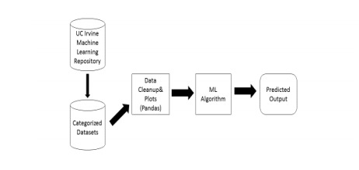

**REQUIREMENTS SPECIFICATION**

**Software Requirements**

**Language:** Python

**Packages:** Pandas, Numpy, Sklearn, Flask

**Framework:** Anaconda

**Front End:** HTML

**Back End:** Machine Learning Mode

**Hardware Requirements**

**Operating System:** Windows OS

**Processor:** i3 or above

**RAM:** 4 GB

**IDE:** Anaconda

**4. METHODOLOGY:**

**4.1. EXISITING SYSTEM:**

Portable devices for the home monitoring of cardiac health are expected to witness substantial growth in coming years. The increasing incidence of cardiovascular disease, the increase in geriatric populations and the demand for independent living are driving the growth of remote monitoring device markets . Electrocardiography (ECG) is still the most widely used diagnostics tool in hospitals and at home. The measurement equipment for ECG, however, is not readily available for most patients, so they must acquire it and learn how to use it. An alternative rhythm management method, mechano cardiograph (MCG), is based on measuring the mechanical motion induced by the heart .Clustering-Based Detection: Unsupervised k-means clustering was used as a second beat detection method. First, all local maxima and minima are computed from the pre-processed signal. Second, the amplitudes of consecutive maxima and minima are considered to be features for the k-means clustering process.The algorithm’s ability to estimate heart rate was evaluated. First, an additional refinement step was carried out since each false peak significantly changes the estimated heart rate.

**4.2.PROPOSED SYSTEM:**

In this study, a sensor modality and algorithm fusion of automatic and stand-alone (ECG-independent) heart beat detection is considered for enhanced heart beat detection. The investigation was carried out with healthy patients and those with heart disease. The algorithm selects the best signal,removes the motion artefacts, detects the beats based on the signal envelope and morphological characteristics, and finally merges the detected beat locations using both accelerometer and gyroscope signals. For these

reasons, beat-to-beat detection from mechanical motion signals with accurate timing and amplitude information is still one of the main challenges in the analysis of these signals.

**SYSTEM ARCHITECTURE:**

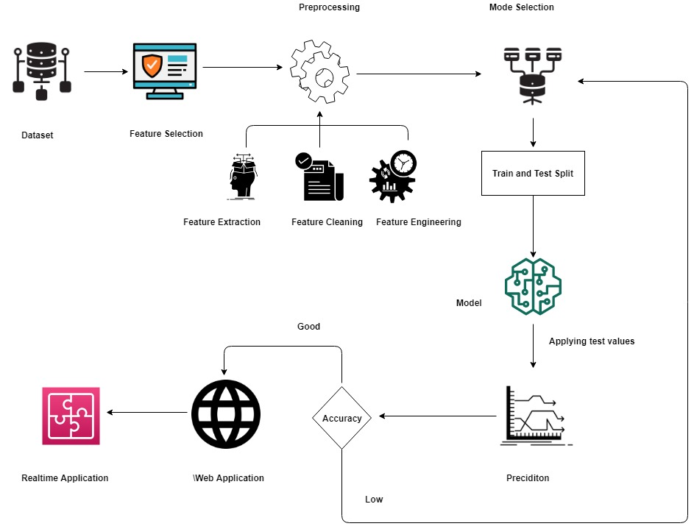

**IMPLEMENTATION & SCREENSHOTS**

**IMPLEMENTATION:**

**1.Data Collection and Preprocessing:**

The data used in this series will be collected from various data sources about the weather of past five years. etc.,).After collecting the every data we have to prepare our data set for weather prediction. Thus dataset contains various data types object like strings, NAN values, etc…to convert this data types we should preprocessing. Preprocessing is the process of preparing the data that can be understandable by machine. Preprocessing of selecting the features that will affect our model and which change in output. After the selection of the Features we will use data to rain our model.

2: **Training and applying algorithm:**

After preparing the cleaned dataset then feature analysis should done. Here, from the dataset choosing the input and output labels (using supervised learning).based on this data we have to train our model. After the training we have to apply classification algorithm in order to predict the weather of particular day with time. Here we use (random forest algorithm for regression).A Random Forest is an ensemble technique capable of performing both regression and classification tasks with the use of multiple decision trees and a technique called Bootstrap Aggregation, commonly known as **bagging**. The basic idea behind this is to combine multiple decision trees in determining the final output rather than relying on individual decision trees.

**3:prediction of Heart Detection:**

Here we created the machine learning module using pickle file. Using this file we can predict the weather by the giving information of the user. Based on the input from the user only model will predict the result input like (Heart Beat,).

**Workflow Diagram**

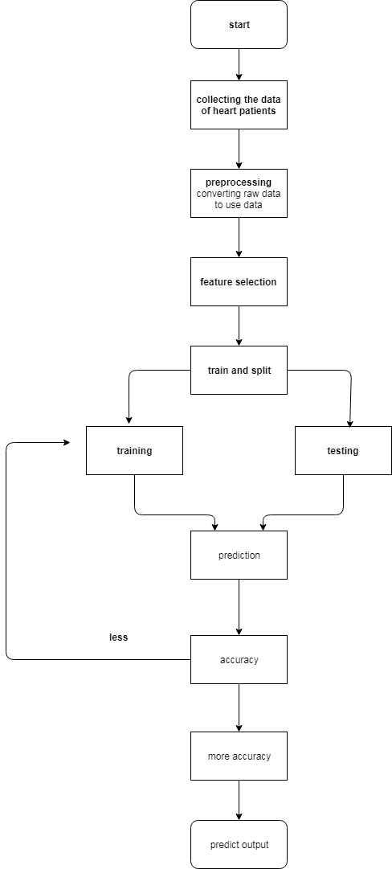

**Class diagram**

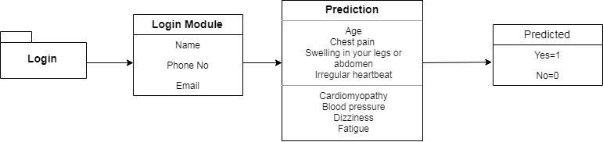

**Use Case Diagram**

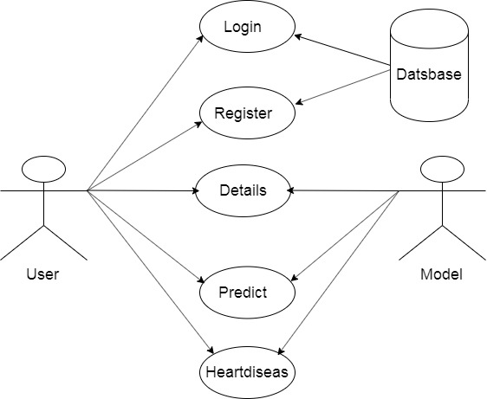

##### **RESULTS**

The output of the system will give a prediction result if the person has a heart disease, in terms of Yes or No. If the person is prone to have heart disease then the result obtained will be Yes and vice versa. In case of an positive output, he needs to consult a cardiologist for further diagnosis. The statistics of the results obtained during the testing of the dataset. Based on the input from the user only model will predict the result input like(AGE,WBC_COUNT,HERAT_RATE,BP,ETC…).

##### **CONCLUSION**

The best axes for most recordings were the z-axis (dorsoven-tral) for accelerometer signals and the y-axis for gyroscope signals (superior–inferior). The axis-selection algorithm was able to identify the best axes in 90% and 96% percent of cases for accelerometer and gyroscope signals, respectively. These results are not surprising given that the sensor placement was carefully controlled in this study, but the results indicate that a simple selection method could be useful for remote health monitoring applications.

**REFERENCES:**

1.H. Ashouri and O. T. Inan, “Automatic detection of seismocardiogramsensor misplacement for robust pre-ejection period estimation in unsu-pervised settings,” IEEE Sensors Journal, vol. 17, no. 12, pp. 3805–3813, June 2017.

2. M. D. Zink, C. Bruser, B.-O. St ̈ uben, A. Napp, R. St ̈ ohr, S. Leonhardt, ̈ N. Marx, K. Mischke, J. B. Schulz, and J. Schiefer, “Unobtrusive nocturnal heartbeat monitoring by a ballistocardiographic sensor in patients with sleep disordered breathing,” Scientific Reports, vol. 7, no. 1, p. 13175, 2017.

3. M. Di Rienzo, E. Vaini, and P. Lombardi, “An algorithm for the beat-to-beat assessment of cardiac mechanics during sleep on earth and in microgravity from the seismocardiogram,” Scientific Reports, vol. 7, no. 1, p. 15634, 2017.

4.T. Hurnanen, M. Kaisti, M. J. Tadi, M. Vah ̈ a-Heikkil ̈ a, S. Nieminen, ̈Z. Iftikhar, M. Paukkunen, M. Pank ̈ a ̈al ̈ a, and T. Koivisto, ̈ Heartbeat Detection Using Multidimensional Cardiac Motion Signals and DynamicBalancing. Singapore: Springer Singapore, 2018, pp. 896–899.

5. M. Kaisti, J. Leppanen, O. Lahdenoja, P. Kostiainen, M. Pank ̈ a ̈al ̈ a, ̈U. Meriheina, and T.Koivisto, “Wearable pressure sensor array for health monitoring,” in Computing in Cardiology 2017 (CinC), Rennes,